**Logic Design Project**

**Submitted By:**

**Hady Maher Abd El-Samee**

**Mai Mahmoud**

**Muhammad AbdulKariim**

**Mohammed Magdy**

**Submitted To:**

**Eng/ Youssef**

**Input Switches Map:**

|  |  |
| --- | --- |
| A1 | First Bit In First Number |
| A2 | Second Bit In First Number |
| A3 | Sign Of First Number |
| B1 | First Bit In Second Number |
| B2 | Second Bit In Second Number |
| B3 | Sign Of Second Number |
| S1 | Add, Sub Selector |
| S2 | Multiplication Selector |

**Output LEDs Map:**

|  |  |
| --- | --- |
| 1st LED | First Bit Of Multiplication |
| 2nd LED | 2nd Bit Of Multi And 1st Of Add |
| 3rd LED | 3rd Bit Of Multi And 2nd Of Add |
| 4th LED | 4th Bit Of Multi And Error Flag In Add |
| 5th LED | Sing LED |

**Sample Input and Output:**

|  |  |  |  |  |  |  |  |  |  |  |  |  |  |
| --- | --- | --- | --- | --- | --- | --- | --- | --- | --- | --- | --- | --- | --- |
| **A3** | **A2** | **A1** | **B3** | **B2** | **B1** | **S1** | **S2** | **LED5** | **LED4** | **LED3** | **LED2** | **LED1** | **MOD** |
| **0** | **0** | **1** | **0** | **1** | **0** | **0** | **1** | **0** | **0** | **1** | **1** | **X** | **ADD** |
| **0** | **1** | **1** | **0** | **1** | **1** | **0** | **1** | **0** | **1** | **1** | **0** | **X** | **ADD** |
| **1** | **1** | **1** | **0** | **0** | **1** | **0** | **1** | **1** | **0** | **1** | **0** | **X** | **ADD** |
| **1** | **1** | **1** | **1** | **0** | **1** | **0** | **1** | **1** | **1** | **0** | **0** | **X** | **ADD** |
| **0** | **1** | **1** | **0** | **0** | **1** | **1** | **1** | **0** | **0** | **1** | **0** | **X** | **SUB** |
| **1** | **1** | **1** | **1** | **1** | **0** | **1** | **1** | **1** | **0** | **0** | **1** | **X** | **SUB** |
| **0** | **1** | **0** | **0** | **1** | **0** | **0** | **0** | **0** | **0** | **1** | **0** | **0** | **MULTI** |
| **1** | **1** | **1** | **1** | **1** | **1** | **0** | **0** | **0** | **1** | **0** | **0** | **1** | **MULTI** |
| **1** | **0** | **1** | **0** | **1** | **1** | **0** | **0** | **1** | **0** | **0** | **1** | **1** | **MULTI** |

**ICs:**

|  |  |  |  |
| --- | --- | --- | --- |
| **ID** | **Number** | **Description** | **Price** |
| **7486** | **3** | **XOR** | **3 L.E** |
| **7408** | **3** | **AND** | **3L.E** |
| **74157** | **1** | **MUX** | **5.5 L.E** |
| **74283** | **1** | **4Bit-Adder** | **13 L.E** |

**Power Supply: 9v Battery and voltage-regulator**

**Main circuit:**

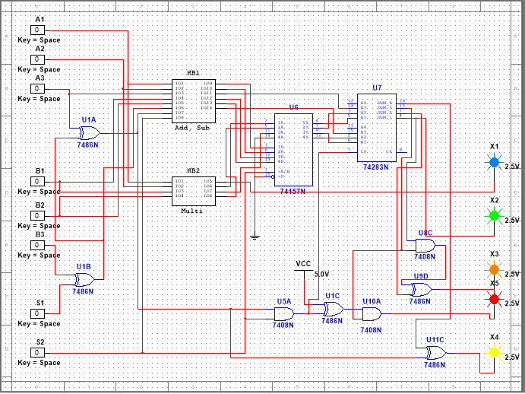

**Sub: Add, Sub:**

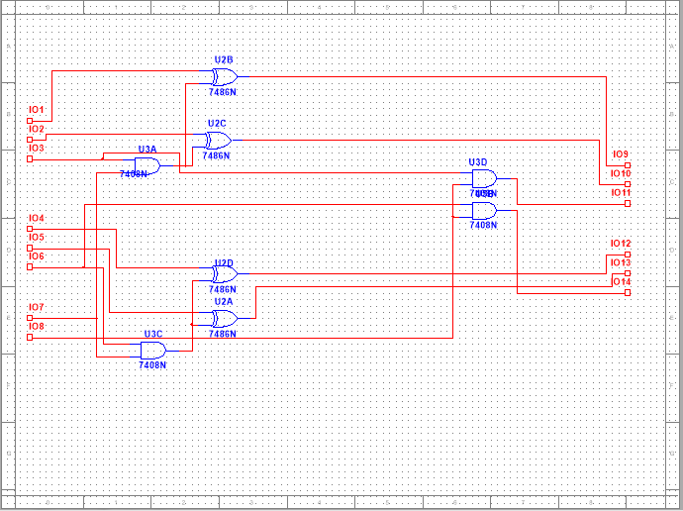

**Multiplier:**

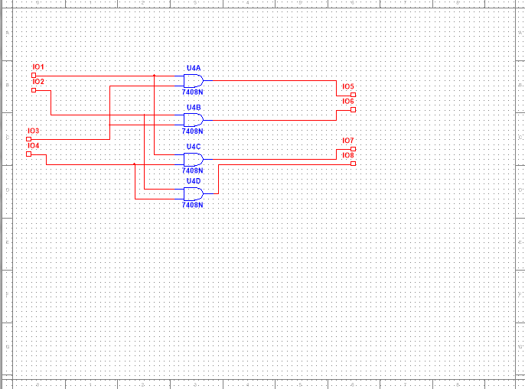

**Design Explanation:**

1. **We used (B3 XOR S1) to detect the sign of the second number.**
2. **({Output of last XOR} XOR A3) to choose the mode of operation whether it is addition or subtraction.**
3. 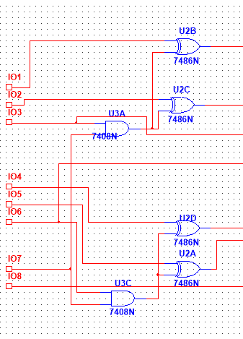**To detect the negative number and make the One’s Complement of the negative number,**

**We use this sub-circuit ->**

1. **We use 4 AND gates to make the multiplication process. **
2. **To choose the mode of operation whether adding or subtration we use an MUX, the selector of MUX is multiplication selector:**

**[1] means adding or subtraction**

**[0] means multiplication**

1. **The output of the MUX is the input of the 4 bit Binary Adder.**
2. **We add the signs in adding and subtraction, and to prevent that in multiplication we use two ANDs.**
3. **ERROR FLAG is the 4th bit in multiplication,**

**And to detect that we use this circuit:**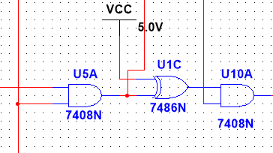

1. 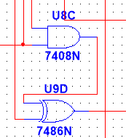**The Output was in 2’s Complement Format, We use this circuit to convert it to signed magnitude Format:**